**Q1. Create a sample table in postgres/mysql with following columns (15 Marks)**

powerbi=# create table cdac_power_bi(Name varchar,Id integer,Age Integer,Dob date);

CREATE TABLE

powerbi=# insert into cdac_power_bi values('Akshay',1,25,'21/9/1997');

INSERT 0 1

powerbi=# insert into cdac_power_bi values('Abubakar',2,25,'8/8/1997');

INSERT 0 1

powerbi=# insert into cdac_power_bi values('Aditya',3,26,'1/8/1995');

INSERT 0 1

powerbi=# insert into cdac_power_bi values('Anushka',4,24,'13/8/1998');

INSERT 0 1

powerbi=# insert into cdac_power_bi values('Amit',5,26,'11/8/1996');

INSERT 0 1

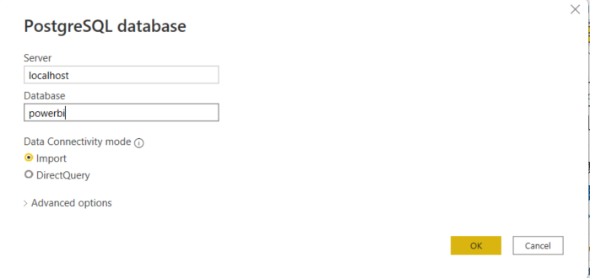

1. Table Chart

2. Card chart showing max age

Final Report:

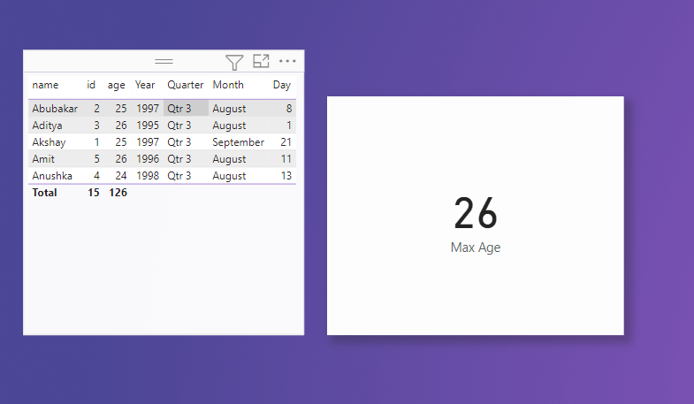

**Q2.On product_table data set do the following (25 Marks)**

● Create table chart with title , vendor,customer name,quantity,price,city

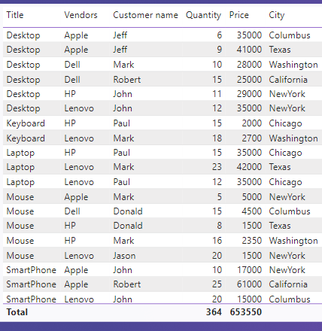

● Add new calculated column naming **total_sales** which is derived from quantity * price

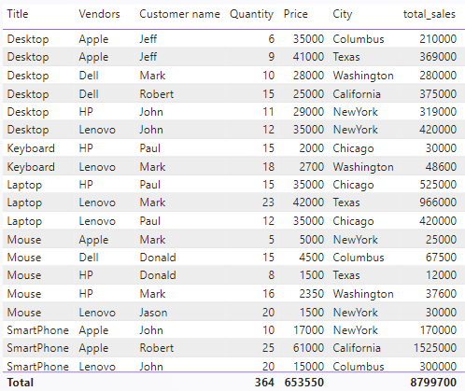

● Add new measure naming max_price to get max of price column and then display every vendor max price in table chart

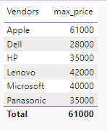

● Create pie chart showing the value and percentage of quantity by vendors

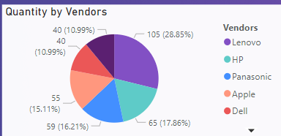

● Create one more column naming **total_sales_2022** which is derived from quantity * price * 1.16

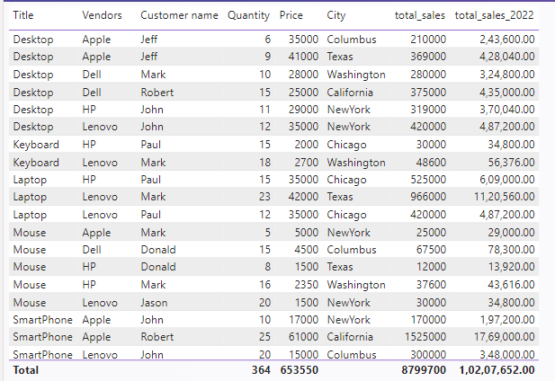

● Create clustered column chart showing both **total_sales** and **total_sales_2022**

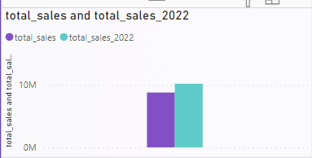

● Create a slicer chart of price

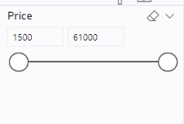

● Calculate avg sales and show in tile

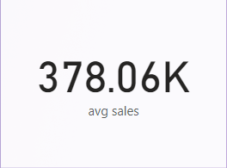

● Create gauge chart with

○ value as total_sales

○ Maximum value as max of **total_sales_2022**

○ Target Value as average of total_sales

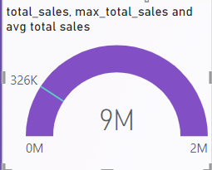

Final Report:

